Experiment No-3
Experiment Name: Demonstration of Loops in Java (for, while, do-while) & Array Implementation.
Task No-1: Print Even Numbers Using while , do-while Loops and Array
Task Name: Write a Java program that takes starting and ending number from user then prints all even numbers in that range using array.

Objective:
To develop a Java program that:
- Takes a starting and ending number as input.
- Stores all even numbers in an array.
- Prints them using while and do-while loops.

Problem Analysis:
We need to:
- Input two numbers — start and end.
- Find all even numbers between them (divisible by 2).
- Store those even numbers in an array.

Algorithm:
- Start.
- Input start and end numbers.
- Initialize an empty array to store even numbers.
- Use a loop to go from start to end:
- If number % 2 == 0, store in array.
5. Print array elements using:
- a while loop.
- a do-while loop.
6. Stop.

Source Code:
import java.util.Scanner;
public class EvenNumbersArray {
public static void main(String[] args) {
Scanner input = new Scanner(System.in);

System.out.print("Enter starting number: ");
int start = input.nextInt();
System.out.print("Enter ending number: ");
int end = input.nextInt();
int[] evenNumbers = new int[(end - start) + 1];
int count = 0;
int i = start;
while (i <= end) {
if (i % 2 == 0) {
evenNumbers[count] = i;
count++;
}
i++;
}
System.out.println("\nEven numbers (using while loop):");
int j = 0;
while (j < count) {
System.out.print(evenNumbers[j] + " ");
j++;
}
System.out.println("\n\nEven numbers (using do-while loop):");
int k = 0;
if (count > 0) {
do {
System.out.print(evenNumbers[k] + " ");
k++;
} while (k < count);
} else {
System.out.println("No even numbers found.");
}
}
}

Output:

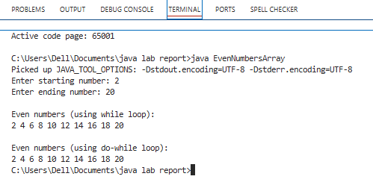

Discussion:
In this task, the program successfully demonstrates how to identify and print even numbers within a given range using both while and do-while loops along with an array. The user inputs the starting and ending numbers, and the program checks each number to determine whether it is even by using the modulus operator (%). All even numbers are stored sequentially in an array, which helps in efficiently managing and displaying the results. The use of both looping structures allows the comparison of how they function: the while loop checks the condition before executing the block, while the do-while loop executes the block at least once before checking the condition. Overall, the program correctly applies array manipulation and loop control structures, showing a clear understanding of iterative programming in Java.

Task No-1: Store and Print Prime Numbers in an Array
Task Name: Write a Java program that takes a starting and ending number from the user and stores only the prime numbers in an array and prints them.
Objective:
To develop a Java program that:
- Accepts a range of numbers.
- Stores only prime numbers in an array.
- Prints all the prime numbers.

Problem Analysis:
We need to:
- Input start and end.
- Check each number for primality.
- Store only primes in an array.
- Print the array elements.
A prime number is a number > 1 divisible only by 1 and itself.

Algorithm:
- Start.
- Input start and end.
- Initialize array to hold prime numbers.
- For each number in range:
- Check if it’s prime (no divisors from 2 to √n).
- If yes, store it in array.
- Print the stored prime numbers.
- Stop.

Source code:
import java.util.Scanner;
public class PrimeNumbersArray {
public static void main(String[] args) {
Scanner input = new Scanner(System.in);

System.out.print("Enter starting number: ");
int start = input.nextInt();
System.out.print("Enter ending number: ");
int end = input.nextInt();
int[] primes = new int[(end - start) + 1];
int count = 0;
for (int i = start; i <= end; i++) {
if (isPrime(i)) {
primes[count] = i;
count++;
}
}
System.out.println("\nPrime numbers in the range:");
if (count == 0) {
System.out.println("No prime numbers found.");
} else {
for (int i = 0; i < count; i++) {
System.out.print(primes[i] + " ");
}
}
}
static boolean isPrime(int n) {
if (n <= 1) return false;
for (int i = 2; i <= Math.sqrt(n); i++) {
if (n % i == 0)
return false;
}
return true;
}
}

Output:
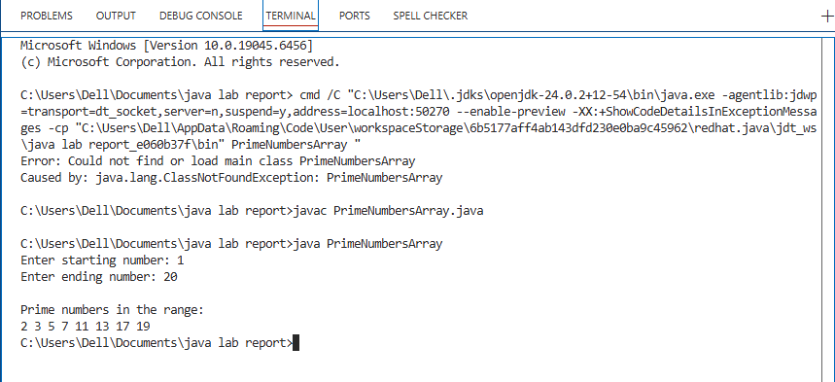

Discussion:
In the second task, the program efficiently identifies all prime numbers within a user-specified range and stores them in an array for display. A prime number is one that is greater than one and divisible only by 1 and itself. The program includes a helper function isPrime() that checks each number’s divisibility up to its square root to determine primality, which makes the process faster and more efficient. All prime numbers found in the range are stored in an array and then printed sequentially. This task highlights the use of functions, loops, conditionals, and arrays in Java, demonstrating how they can work together to solve a mathematical problem. The implementation is logical, efficient, and easy to understand, successfully achieving the objective of identifying and displaying prime numbers from a given range.

